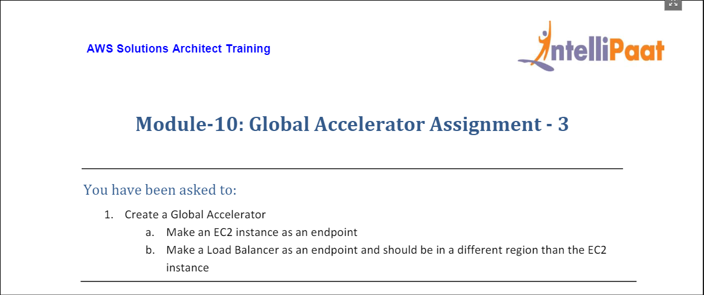

1. For this exercise, we begin by creating an EC2 instance in N. Virginia region.

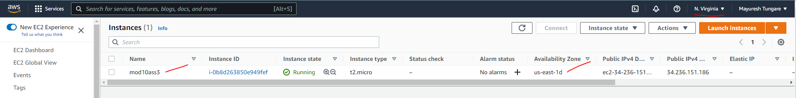

1. Next, we create a Load Balancer in Oregon region (different region).

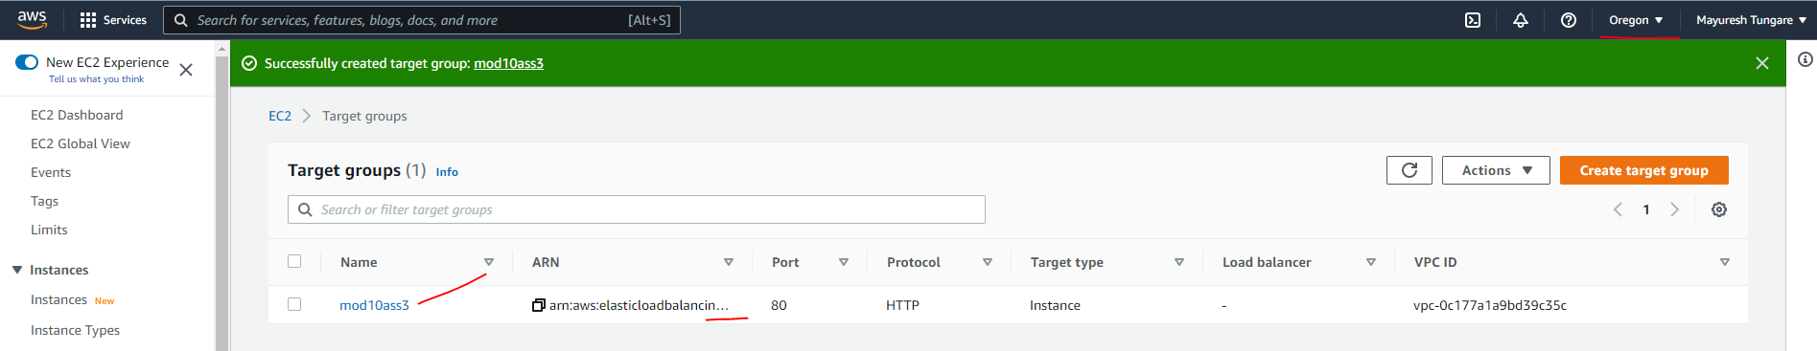

1. Now, we create Global Accelerator.

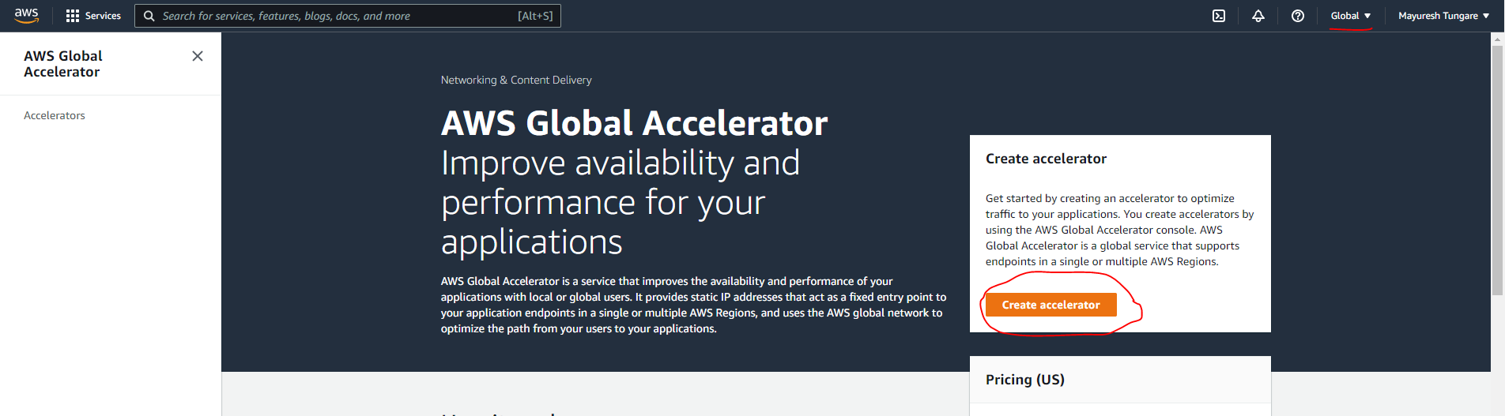

1. On next screen, we add details as below

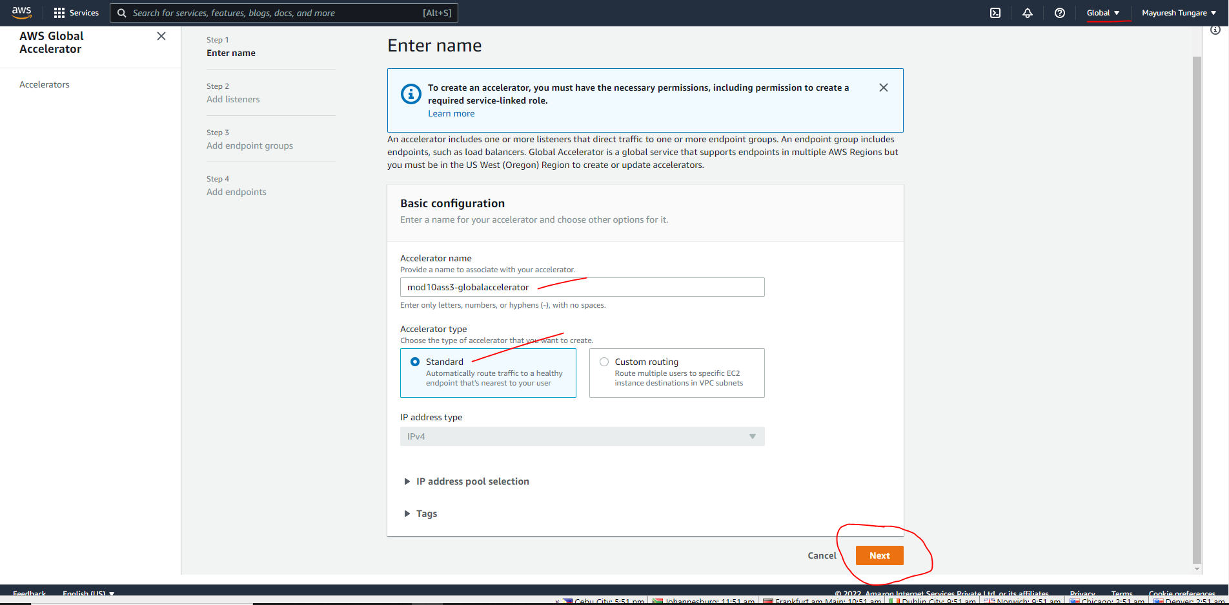

1. We add listener information as below:

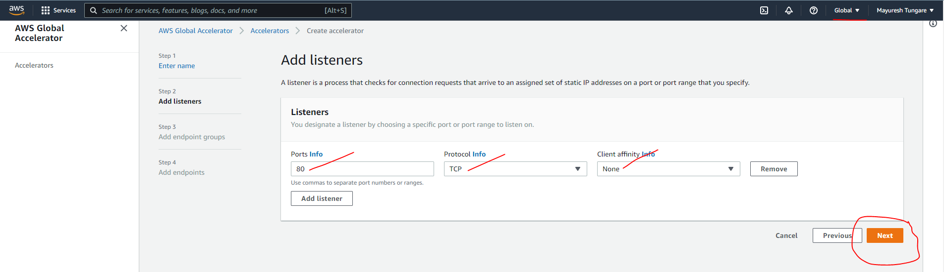

1. We add endpoint groups for the EC2 instance (from step 1) and the Load Balancer (from Step 2)

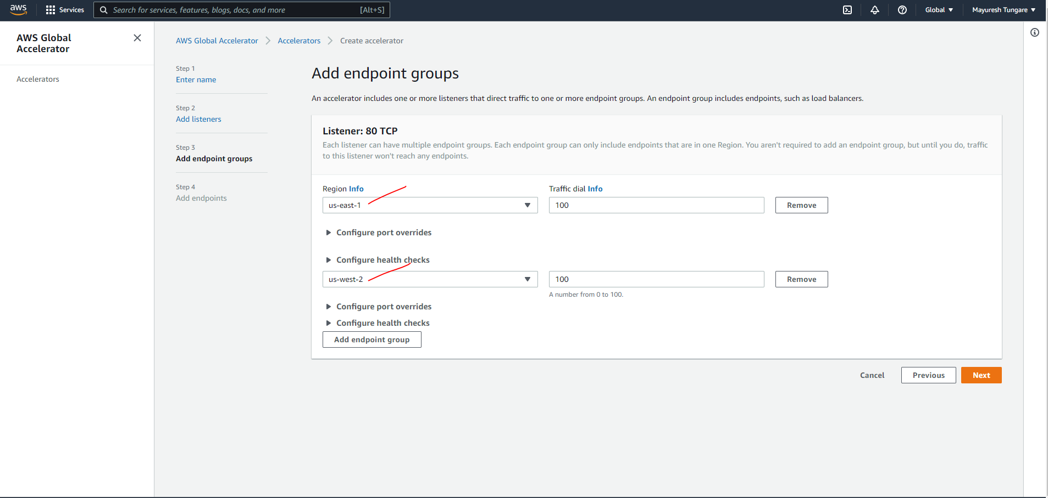

1. In next step, we add the endpoints as shown below:

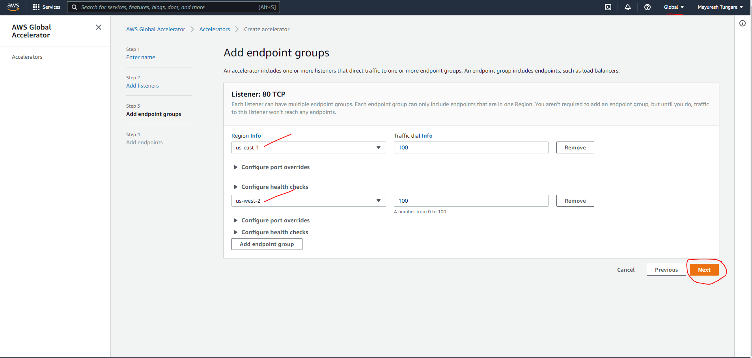

1. We now see the Global Accelerator created as shown below:

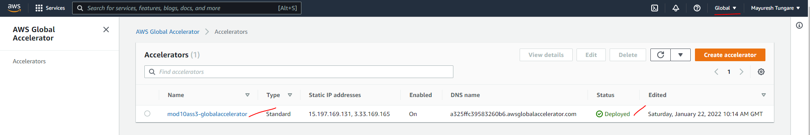

1. Thus, the assignment is now complete.